# **Project Documentation: Airbnb Host Clone**

## **1. Application Execution**

This section demonstrates the successful startup of the React.js application using the development server.

### **Running the Application**

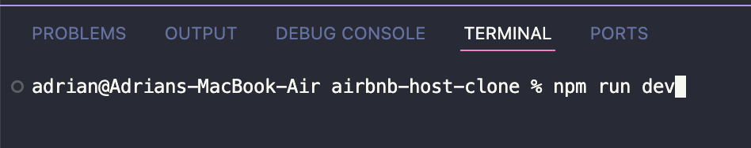

### **Terminal Output: Application Startup**

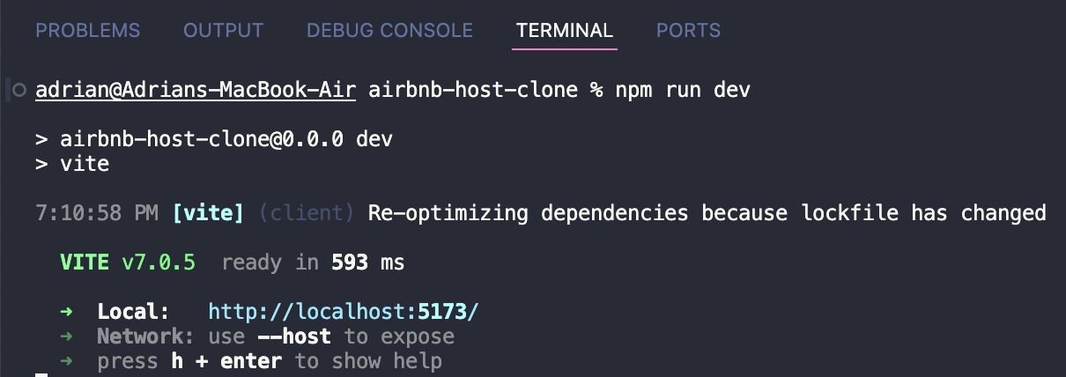

**Figure 1:** Terminal output showing the successful compilation and startup of the React.js application.

## **2. Unit Test Execution**

This section verifies the functionality of the application's components through unit tests.

### **Running Unit Tests**

To execute the unit tests, navigate to the project's root directory in your terminal and run:

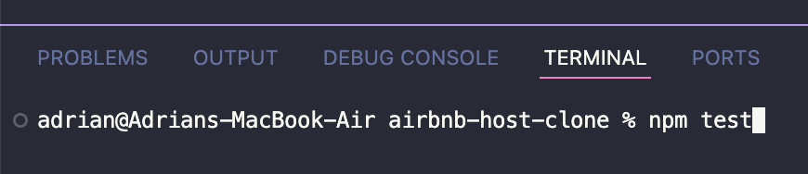

### **Terminal Output: Unit Test Results**

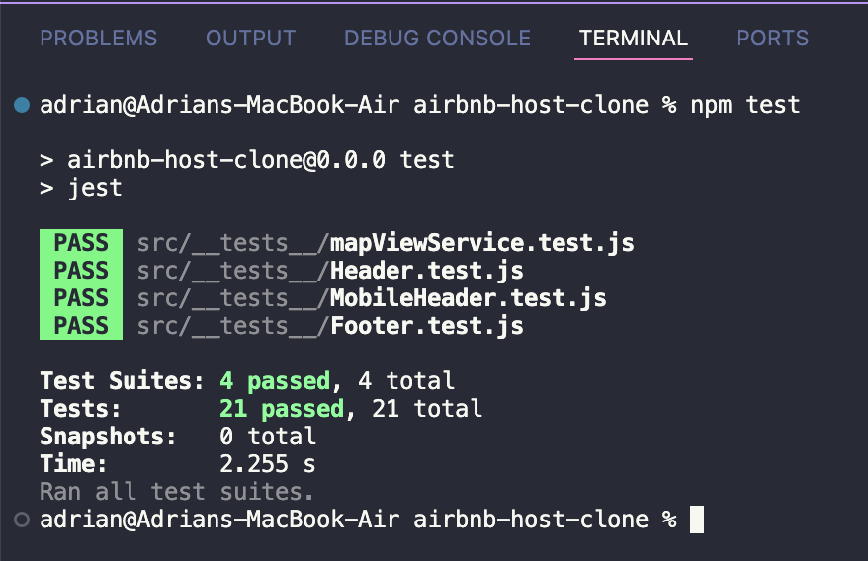

**Figure 2:** Terminal output displaying the results of the unit test suite, confirming all tests passed.

## **3. Application Preview in Browser**

This screenshot shows the Airbnb Host clone homepage rendered in the browser, demonstrating that the frontend is functioning as expected.

